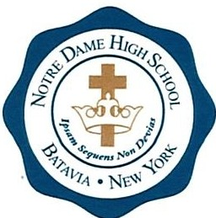

REQUEST FOR RELEASE OF SCHOOL RECORDS
This form must be completed and returned to Notre Dame High School.

Student's Full Name:
Date of Birth: | Last attended school:

To Whom It May Concern:

Please forward the following regarding the above named student:
- Transcript of academic records
- Test scores
- Attendance records
- School profile and/or interpretation of your grading system
- Health and immunization records
- Copy of IEP or 504/Declassification letter
- Any other information that is pertinent to the student's academic success

All information should be sent to:
Notre Dame High School Attn: Advisement Office
73 Union Street
Batavia, NY 14020
OR
Fax: 585-345-0644 / Email: Kristen.gomez@ndhsbatavia.com

Call the Advisement office at (585) 343-2783 ext. 138 if you have any questions. Thank you.

Parent/Guardian's Signature Date

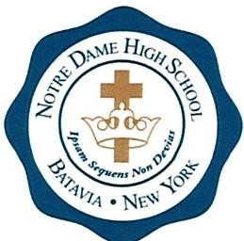
REQUEST FOR TRANSPORTATION TO NON-PUBLIC SCHOOL
This form must be completed even if the student will not require bus transportation.

Student's Name:

Last First

Student's Address:

Number and Street

City State Zip Code

Parent/Guardian Name:

Public school district in which I live:

Fill in one of the following descriptors for your address:
- I live within the city/village of

- OR -

- I live on Road, which is between

Road and Road.

I hereby appoint the Principal of Notre Dame High School, Batavia, NY, to act as my authorized representative in requesting transportation to school under the provisions of the Speno Law for
Student's Name

Parent/Guardian Signature Date
Please note: Some districts will require an additional form specific to their district

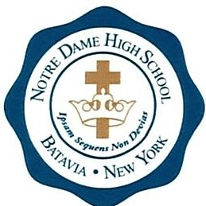

TEXTBOOK REQUEST FORM

TB 1
New York State Textbook Loan Law

Student's Name:

Student's Address:

Number and Street

City State Zip Code

Public School District:

LOAN OF TEXTBOOKS

I hereby request the Loan of Textbooks in the name of
Students Name

I authorize the Public School District to act on behalf of this student
School District Where You Reside

with identifying and ordering books loaned to the student identified above, and residing in the district above. Each book received by the student must be maintained in good condition. If a book is damaged or lost, the student will be responsible for replacing the book as new.

Parent/Guardian's Signature Date

This form is to be kept on file in the individual non-public school for the duration of the student's enrollment.

